The Role of the Judiciary in Asylum and Other International Protection Law in Asia

-A conference for judges and judicial decision-makers in Asia-

Asian Network on Refugee and International Protection (ANRIP)

Date: June 9th-11th, 2016

Venue: The Judicial Research and Training Institute (Seoul, Korea)

Hosts: IARLJ, ANRIP, The Judicial Research and Training Institute, UNHCR Korea

Written by : Sayaka Watanabe, Jang Mirom, Jafar Atayee



**[Outline]**

1. Introduction
   1. What ANRPI is?
   2. What IARLJ is?
2. Training Workshop
3. Conference Day 1
   1. Opening Ceremony / Keynote Speeches
   2. The Role of the Judiciary in Protection of Refugees and Asylum Seekers and Other Non-Refoulement Obligations
   3. Procedural Reforms and Challenges of Refugee Protection in Various Jurisdictions
   4. Due Process for Claimants at Ports of Entry and on the High Sea
   5. Discussion on Possible Regional (Asia Pacific) and International Judicial Cooperation on Refugee and other International Protection

4. Conference Day 2

a. International Protection for North Korean Defectors and their Children

b. Protection of Asylum Seekers beyond the 1951 Refugee Convention and in

Non-State Parties

5. Report of Asian Network on Refugee and International Protection (ANRIP)

# **[Summary]**

From 9th to 11th June, an international conference for judges and judicial decision-makers were held at the Judicial Research and Training Institute in Seoul, Korea. The participants are not only from Asian-Pacific countries but also from other Europe countries. They shared and had discussions about present situation of each countries, challenges, and solutions.

Besides this conference, ANRIP(The Asian Network for Refugees and International Protection) second meeting was held.

**===== 1, Introduction==================================**

1. What is IARLJ

　The International Association of Refugee Law Judges seeks to foster recognition that protection from persecution on account of race, religion, nationality, membership in a particular social group, or political opinion is an individual right established under international law, and that the determination of refugee status and its cessation should be subject to the rule of law. The regional activities are organised within the Chapters. At present the Association has a European Chapter, an American Chapter, an Australasian Chapter and since 2005 an African Chapter.

b) What is ANRIP

　ANRIP (Asian Network for Refugees and International Protection) is an organization established in December 2014 after an international conference at the University of Tokyo on Refugee law and practice. As Asia has significant numbers of refugees, asylum-seekers and other persons who are in need of international protection, ANRIP aims at forming the platform to share information and good practices between the members. Its Goals are to promote the rule of law and the application of international standards in Refugee and International Protection decision-making process.

**=====2. Training Workshop day (9th June)===================**

Introductory Workshop on Refugee Convention and International Law

Speakers: Linda Kirk(Chair IARLJ Australian Chapter) Martin Treadwell (New Zealand)

**Outline**

1.Introduction

2.Who is to be recognized as a Refugee?

3.What are the Rights of Refugees?

4.Fundamental International Human Rights Norms Define Serious Harm

5.Human rights are found in

6.Well-Founded Fear

7.A Nexus to a Convention Reason

8.The Convention Reason

9.Complementary Protection

10.Complementary Protection in Practice

11.Harm

12.Complementary Protection (CP) where Refugee Status is granted

**1.Introduction:**

On June 9th two workshops were held which were introductory/refresher course in refugee protection law and advanced workshops in refugee and protection law. The students from the University of Tokyo joined the introductory workshop, while the rest of the members of ANRIP joining IARLJ conference joined advanced workshop. The areas of Refugee Convention and International Law was lectured at the introductory workshop which is introduce below:

Mr. Martin Treadwell and Ms. Linda Kirk were the two lecturers who talked on the Refugee Convention and International Law. They touched upon different, yet crucial, areas of the Refugee Convention and International Law. Beside defining refugees, Mr. Treadwell stressed upon matters such as: refugee status to be declaratory, claimants must be treated as refugees while their claims are processed, and refugees must not be returned to the country of persecution except if the refugee is a threat to the security of the community of country.

**2.Who is to be recognized as a Refugee?**

　A refugee is a person who:

“As a result of events occurring before 1 January 1951 and owing to well-founded fear of being persecuted for reasons of race, religion, nationality, membership of a particular social group or political opinion, is outside the country of his nationality and is unable or, owing to such fear, is unwilling to avail himself of the protection of that country; or who, not having a nationality and being outside the country of his former habitual residence as a result of such events, is unable or, owing to such fear, is unwilling to return to it”. - Article 1A (2)

**3.What are the Rights of Refugees?**

The understanding of refugee issues are expanding as the person`s bond to the receiving state increases. The refugee rights can be divided into four areas and they differ at each area/state. Firstly, refugees within the jurisdiction of the receiving state. Refugees at this stage have the rights: non-discrimination, moveable and immovable property, access to court, rationing, education, freedom, non-refoulement, and naturalization. Secondly, once the person is on the territory of the receiving state, at this stage: refugees have the rights to have freedom of religion, receive identity papers, freedom from penalization for illegal entry, and subjected only to necessary and justifiable constraints on freedom of movement. Thirdly, refugees have rights against expulsion, more generous guarantee of internal movement.

Ms. Kirk described a refugee as a person who is “owing to a **well-founded fear of** **being persecuted** for reasons of race, religion, nationality, membership of a particular social group, or political opinion…” Ms. Kirk stressed upon well-founded fear of being persecuted which she divided it into two things: **serious harm** and **the absence of state protection**. So, serious harm + failure of state protection = persecution.

In addition, she puts emphasis on the predicament of the claimant rather than the motive of the persecutor. The asylum laws in Canada, New Zealand, and Europe describes being persecuted as the “sustained or systematic violation of basic human rights demonstrative of failure of state protection”, which is the best methods to describe and provide protection laws for refugees.

Ms. Kirk stresses upon the importance of **human rights** in order to protect refugee rights. She claims human rights provide an objective standard separate to domestic laws and morality. Which also avoids making political judgment about practices of another country, meaning that the Refugee Convention remains flexible – can respond to new threats to human dignity and maltreatment. In addition, ICCPR and other core treaties are widely ratified – does not infringe on states` sovereignty to hold them to those standards and provides an objective standard separate to domestic laws and mortality.

**4.Fundamental international human rights norms define serious harm:**

· Consistent with purpose of Refugee Convention

· As explained in Preamble to Refugee Convention

· Widely approved (NZ, UK, UNHCR, Canada, ECHR)

Still begs the question: “Where are fundamental human rights articulated?”

**5.Human rights are found in:**

1. Non-derogable ICCPR rights like protection against arbitrary deprivation of life, torture or cruel treatment.

2. Other ICCPR rights like rights to religion, private and family life.

3. ICESCR rights, e.g. rights to work and housing (where these are denied on a discriminatory basis).

Why use human rights as the yardstick (standard for judging)?

· It is the core international human rights norms which define serious harm.

· Human rights are explicitly referred to in the Preamble (“UN Charter and UHDR have affirmed the principle that human beings shall enjoy fundamental rights and freedoms without discrimination…”)

· To look to them is consistent with the purpose of the Convention.

· Pragmatism.

· Provides an objective standard separate to domestic laws and morality.

· Avoids making political judgments about practices of another country.

· Means that refugee convention is flexible – can respond to new threats to human dignity and maltreatment.

· ICCPR and other core treaties have been widely ratified – does not infringe on states’ sovereignty to hold other states to those standards.

· Avoids subjectivity and intellectual laziness (“I know it when I see it”).

· To allow refugee protection to be granted to those who are not mentioned in the Convention, i.e.:

1. Sexual orientation

2. Gender

　The Convention thus remains a dynamic, evolving document.

**6.Well-Founded Fear:**

In terms of Refugee Appeal No 70074, the principle issues are:

a. Objectively, on the facts as found, is there a real chance of the appellant being persecuted if returned to the country of nationality?

b. If the answer is yes, is there a Convention reason for the persecution?

So, a fear is well-founded when there is:

· Objectivity

· A real chance

· Of it occurring in the future

**7.A nexus to a convention reason:**

The convention does not seek to offer protection from all types of serious harm.

It is aimed at harm arising out of particular types of socio-political status.

The anticipated predicament must arise “from reason of” one or more of the convention grounds.

**8.The Convention reason:**

　The Convention ground does not have to be an actual attribute of the claimant. It suffices that the persecutor perceives the existences of the attribute, or even has the attribute itself. Where the persecutor perceives that the claimant has the attribute, say a political opinion, we speak of “an imputed political opinion”. There could be reasons such as race (ethnicity, tribe, clan), religion (the right to religion includes the right not to have a religion), political opinion, nationality (citizenship) and particular social group (women, children, lesbian, gay, bisexual, transgender, intersex, and albino).

**9.Complementary Protection:**

The principle of complementary protection derives from States’ non-refoulement obligations under international law.

“The term ‘complementary protection’ describes States’ protection obligations arising from international legal instruments and custom that complement- or supplement term for the widened scope of non-refoulement under international law”. The term has emerged so as a description of the increasingly-apparent phenomenon in industrialized countries of *relief from removal being granted to asylum seekers who have failed in their claim for 1951 Convention refugee status.*

**10.Complementary Protection in Practice:**

The essential elements are:

· Evidential requirement-“substantial grounds for believing”.

· Degree of risk- “in danger of”.

· Harm – “torture / arbitrary deprivation of life / cruel treatment”.

**11.Harm:**

Severity of harm and nature of harm must be taken into consideration, because they are to distinguish whether one needs refugee law protection. However, this does not mean that sufferers of all forms of serious harm are entitled to refugee law protection.

**12.Complementary Protection (CP) where Refugee Status is granted:**

Recognition of refugee status renders the person not liable for deportation, unless permissible - there is evidence a person is found to be refugee is not at risk of refoulement and they do not require recognition as either CAT or ICCPR protected person. Those aspects of the appeal must inevitably be declined.

**==== 3. Conference day 1 =============================**

**a. Opening Ceremony / Keynote Speeches**

|  |  |
| --- | --- |
| Chair: | Lee Kyoo Jin (Chair of the Korean Judge’s Society) |
| Speakers: | Cho Yonggu (President of the JRTI) / Katelijne Declerck (IARLJ-Belgium) / Naveed Hussein(UNHCR Representative, Republic of Korea) |

Naveed Hussein(UNHCR Representative, Republic of Korea)

I am delights that my office here in Seoul has had the opportunity to provide support over the past many months to assist the IARLJ and the JRTI to organise this very important event here in Seoul. Korea became a signatory to the 1951 Refugee Convention in 1992 and gradually, over the following years, started to establish procedures and regulations relation to the status of refugees in it’s territory.

In 2015, almost 6,000 individuals applied for asylum, the highest number on record and dramatic increase from only a few years ago when very few asylum seekers were processed in Korea. Many rejected asylum seekers have appealed to the court system here in Korea and Korean judges in variety of different courts are experiencing drastically increased volumes of refugee cases, which presents significant challenges and it s my earnest hope that this conference, with such a strong representation of Korean judges, will generate valuable professional exchange on how to confront these challenges.

In the Secretary General’s recent report on 21 April on addressing large movements of refugees and migrants, he motes the unprecedented urgency for sharing the burden of refugees and proposed a new Global Compact for more equitable sharing of the task of protecting refugees. The current situation were less than 10countries host more than 80% of the world’s refugees is intolerable and cannot continue. The crisis in refugee protection does not arise because there is something wrong with existing refugee law. The 1951 Convention remains the wealthered but sturdy bedrock of refugee rights- non-refoulement, not refusing admission of asylum seekers at the frontiers, not penalizing refugees for their lack of documents or their inability to furnish comprehensive proof of their reasons for flight.

I offer my particular encouragement for the final session of today’s proceedings in which judges from the Asia-Pacific region will discuss possible mechanisms for closer regional judicial cooperation.UNHCR Seoul has been privileged to be able to play a supporting role in organising this event and we look forward to some very live and interesting exchange of idea and strengthening of professional networks in the region.

**b. The Role of the Judiciary in Protection of Refugees and Asylum Seekers and Other Non-Refoulement Obligations**

|  |  |
| --- | --- |
| Chair: | Myeongsu Kim (Chief Judge of Chuncheon District Court) |
| Speakers: | Justice M Kirby (Australia) / Justice Kwon O-Gon / Judge Ahn Seong Hoon |

Current Status of Korean Court regarding Refugee Litigation

Myeongsu Kim (Chief Judge of Chuncheon District Court)

1. Preface

Republic of Korea has deposited instrument of ratification of the Convention Relating to the Status of Refugees and the Protocol Relation to the Status of Refugees on December 3, 1991. Accordingly, the former was ratified on March 3, 1993 and the latter on December 3, 1992. In 1994, Immigration Control Act was revised to include articles providing for refugees, and finally in 2012, an independent Refugee Act was enacted and has been enforced since July 1, 2013.

Accordingly, the first application for refugee status was made in 1994, and the refugee status determination procedure under the purview of the Ministry og Justice as well as the administrative litigation on the refusal of the recognition of refugee status also began to take place. While the “Refugee System” was implemented in 2014, the number of applications was initially only two to eighty per year. It has grown to more than hundred in 2004, and over a thousand applications are being submitted per year since 2011. In 2014, the number reached 2,896, topping 2,000 for the first time. In 2015, which was last year, it skyrocketed to 5,711, and is expected to increase steadily in the future.

In order to address the sharp increase in number of refugee cases, courts of Korea, especially the Seoul Administrative Court which processes most of the domestic refugee cases, have published the manual named “Understanding Refugee Litigation” in 2011, and after the enactment of the independent Refugee Act in 2012, published “Understanding Refugee Trials”, a revised version of the former publication, in 2013. This manual, which includes the history of refugee system, introduction on the theory and practice of refugee litigation procedures as well as other practical information, has been serving as an essential tool in assisting the courts. This very remark was written with extensive help from the manual.

2. Caselaw on Recognition of Refugee Status

a. Requirement for Refugee Status

There are two noticeable Supreme Court decisions on the most important requirement for recognition of refugee status, “well-founded fear.”

1. Supreme Court Decision 2007Du3930 Decided Jul. 24. 2008
2. Supreme Court Decision 2010Du27448 Decided Apr. 26. 2012

b. Litigation Procedure

1. Cooperation with Refugee Aid Organizations
2. Assistance from Legal Professionals
3. Interpretation
4. Closed Hearing
5. Collection of Favorable Evidence
6. Country of Origin Information (COI)
7. Applicant’s Own Testimony

3. Conclusion

There recently has been an increase in refugee applications, leading to a rising public interest and more court decisions. Nevertheless, based on my personal experience, there have not been a lot of refugee cases where the applicant was recognized to have the “well-founded fear of persecution” under the five requirements of the Refugee Act.

The Supreme Court of Korea follows international standard in where and how much the burden of poof lies. Yet it is also true that the court decisions do not seem to fully reflect the special circumstances that refugees encounter.

**c. Procedural Reforms and Challenges of Refugee Protection in Various Jurisdictions**

|  |  |
| --- | --- |
| Chair: | Judge Lee Jinman (Seoul Administrative Court) |
| Speakers: | Professor Kohki Abe (Japan) / Judge Ha Tai Heon / Judge Torres (Philippines) |
| Commentator: | Allan Mackey (IARLJ) - RSD judicial guidance charts |

Procedural Reforms and Challenges of Refugee Protection in Japan:

A Brief Critical Portrayal

Kohki Abe (Professor of International Law Kanagawa University School of Law)

Japan helps too few refugees

Reasons

1. Because “genuine” refugees do not choose Japan?
2. Because other countries are too lenient in helping refugees?
3. Because Japan pursues too strict a policy in handing refugees?
4. Accession to the 1951 Refugee Convention and its 1967 Protocol, effective in 1982

State’s quest for international legitimacy; it means reshaping Japan’s identity appropriate for a world economic power democratically developed country. However there is weak domestic constituency for avocation the incountry refugee protection.

1. Refugee Recognition Procedures to implement the Refugee Convention / Protocol

Japanese government enacted the Immigration Control and Refugee Recognition Act in 1982. It created the Refugee Determination Procedure

1. Domestic and international criticism

-Amnesty International

Japan: Inadequate Protection for Refugees and Asylum-seekers

-Academics

Refugee Recognition Procedure in Japan: Proposals for Reform (1993)

-UNHCR

“A strict time limit for making an application for asylum and an unusually high standard of proof meant that between 1990 and 1997, fewer than 4% of these were recognized as refugees under the Convention”

1. First Major revision of the Procedure

A bill to revise the Immigration Act (2005)

-Elimination of 60-day time limitation

-Provision for permission for provisional stay for certain asylum-seekers

-Establishment of the Refugee Examination Counselor in the appeals stage

1. Institutional Problems

-Lack of independence

-Lack of expertise

-Lack of transparency

-Inadequate COI (Country of origin information)

-No effective judicial remedy

1. Newly Emerging Circumstances

-Increase in the number of asylum applicants including repeat applications

-Increase in the number of applicants who abandon the rights to have their cases heard in the second instance

-Increase in the number of pending cases

-Prolongation of period for decision-making

1. Current Governmental Endeavors to Address the Problems

-Enhancement of promptness

-Clarification of criteria for determination

-It is urged that international normative documents such as UNHCR’s Position on Manifestly Unfolded Applications for Asylum and series of UNHCR’s Guidelines and Notes on themes relevant to the concept of refugee are properly accommodated in the policy making by the Government

1. Challenges Ahead

-Unstable political situations in East Asia and furtherance of securitization of border control

-Lack of political will to address refugee problems

-Needs of training on international refugee law and international human rights/humanitarian law

-Enhancement of the quality of decisions in conformity with international standards

-Institutional support for obtaining and analyzing reliable COI

**d. Due Process for Claimants at Ports of Entry and on the High Sea**

|  |  |
| --- | --- |
| Chair: | Katelijne Declerck (KDC) |
| Speakers: | Carole Dahan (UNHCR) / Linda Kirk (Australia) / Judge Lim Taehyuk (Seoul Central District Court) |
| Commentators: | Judge Michael Hoppe (Germany) / Lee Il (Attorney, Korea) |

“Between the Devil and the Deep Blue Sea”:

“Enhanced Screening” of Asylum-Seekers in Australian Waters

Linda Kirk (Deputy Director and Sub-Dean Migration Law Program, ANU Collage of Law)

[Enhanced Screening]

-In October 2012, the Australian Labor Government began a process of pre-screening certain asylum seekers arriving in Australia.

-So called “Enhanced screening” initially applied only to Sri Lankan nationals arriving by sea without a valid visa.

-Under Labor, asylum-seekers were subjected to ”Enhanced screening” upon arrival to the Australian mainland.

-The purpose of “Enhanced Screening” is to obtain information about a person’s reasons for coming to Australia, and “Screen out” those people who do not raise a claim that could reasonably engage Australia’s protection obligations.

-Those who immigration decision-makers deem may engage Australia’s international protection obligations are “Screened in” and are allowed to enter the protection determination process.

[Australian Human Rights Commission Report]

-In August 2015, the Australian Human Rights Commissioner, professor Gillian Triggs, delivered her report in response to complaint made by two Sri Lanka asylum-seekers who were “Screened out” and returned to Sri Lanka in November 2012 without the Australian authority is conducting a full assessment of their protection claims.

-The Commissioner concluded that the failure of the Department to conduct a full assessment of their claims and return them to Sri Lanka raised a real risk that they would be subject to treatment prohibited by Article 7 of the International Covenant on Civic and Political Rights.

-The Commissioner found that the enhanced screening process contains a number of significant risks that people with substantive claims for protection will not be identified.

1. Asylum-seekers are not informed that they have a right to request legal advice
2. They are not asked directly whether they have concerns about being returned to their country of origin.
3. Officers may screen out asylum-seekers who make claims for protection if the officer believes that the claims are not sufficiently material.
4. Asylum-seekers subject to a decision to screen them out are not given a written record of this decision as a matter of course and are not informed of their right to seek judicial review of this decision.

**e. Discussion on Possible Regional (Asia Pacific) and International Judicial Cooperation on Refugee and other International Protection**

|  |  |
| --- | --- |
| Chair: | Judge Kim Seongsoo |
| Discussion Panel: | IARLJ (KDC & Martin Treadwell) / Judge Lee (Korea) / Miki Arima (Japan) /Philippines rep / HK TCAB rep / Rick Towle (UNHCR, Malaysia) |

**==== 4. Conference day 2 =============================**

|  |
| --- |
| **International Protection Obligations in Large-scale Displacement Crises**  **Expanded Refugee Concept in the World and in Asia**  **Chair:** Sebastiaan de Groot IARLJ (Ne)  **Speakers:** Janice Marshall (UNHCR) / Judge Lee Il (Korea) / Judge Michael Hoppe (Germany/EU)  **Commentators:** Yukari Ando (Osaka University, Japan) |
| **International Protection for North Korean Defectors and their Children**  **Chair:** Kang Seung Joon (JRTI)  **Speakers:** Justice M Kirby (Australia) / Judge Ahn Seung Hoon (Seoul Central Court) / Ahn Younkyo(OHCHR)  **Commentators:** Judith Gleeson (UK) / Hwang Pilkyu (Attorney, Korea) |
| **Protection of Asylum Seekers beyond the 1951 Refugee Convention and in Non-State Parties**  **Chair:** Bridget Dingle (New Zealand)  **Speakers:** Kelly Loper (Hong Kong) / M Treadwell (New Zealand) / Judge Ha Jung Hoon (Gunsan branch, Jeonju District Court, Korea)  **Commentators:** Patricia Goedde (SKK Univ KR) / Judge Michael Hoppe (Germany-EU) |

**１．Application of the Refugee Convention to North Korean Defectors and Their Children**

Most North Korean defectors enter Republic of Korea(South Korea) directly by using a false passport or via other third countries such as China, Thailand and Mongolia.

China is a signatory state to the 1951 Convention Relating to the status of Refugees. However, it has returned those illegally entered China from north Korea based on the following grounds; 1) North Korean defectors are not refugees but economic migrant crossing the border illegally, failing to meet the requirements of refugee under Refugee convention. 2) China also argues that it has the right to treat North Korean defectors according to Chinese domestic law and the bilateral agreement between china and North Korea

Application of the Refugee Convention to North Korean Defectors and their children

Main issues relating to North Korean defectors can be summarized as follows.

1) If North Korean defectors who seem to have crossed the border of China in search of economic stability are forced to return to North Korea, is there well-founded fear of being persecuted?

2) Do these North Korean defectors meet any of the five grounds of persecution stipulated in the Refugee Convention?

3) As North Korean defectors hold nationality of Republic of Korea in accordance with Republic of Korea’s Constitutions, would it be against the complementary nature of Refugee Convention if they seek for refugee status in the third country without making the same application to Republic of Korea?

4) How should we understand the contradiction of the bilateral agreement between China and North Korea and the provisions of non-refoulement in the Refugee Convention.

**Existence of well-founded Fear of being persecuted**

United Nations Human Rights Council (UNHRC) has established the Commission of Inquiry on Human Rights in the Democratic People’s Republic of Korea (COI) to examine human rights violations in North on 2013.

Below is one of the important parts of the major findings of the COI report.

**42．The State imposes a virtually absolute ban on ordinary citizens travelling abroad, thereby violating their human right to leave the country. Despite the enforcement of this ban through strict border controls, nationals still take the risk of fleeing, mainly to China. When they are apprehended or forcibly repatriated, officials from the Democratic People’s Republic of Korea systematically subject them to persecution, torture, and prolonged arbitrary detention and, in some cases, sexual violence, including during invasive body searches. Repatriated women who are pregnant are regularly subjected to forced abortions, and babies born to repatriated women are often killed. These practices are driven by racist attitudes towards interracial children of Koreans, and the intent to punish further women who have left the country and their assumed contact with Chinese men. Persons found to have been in contact with officials or nationals from the Republic of Korea or with Christian churches may be forcibly “disappeared” into political prison camps, imprisoned in ordinary prisons or even summarily executed.**

In lights of results of these investigations, North Korean defector’s fear of receiving serious threats to life and freedom of liberty when being repatriated is well founded.

**Grounds of Persecution-Political opinions**

The mere fact of refusing to avail oneself of the protection of his Government, or a refusal to return, may disclose the applicant’s true state of mind and give rise to fear of persecution. In such circumstances the test of well-founded fear would be based on an assessment of the consequences that an applicant having certain political dispositions would have to face if he returned.

**Is a North Korean defector a pure economic migrant?**

North Korea utilizes food as a means of controlling their citizens under the planned economy system. By closely analyzing the essence of this system, it may be interpreted that many North Korean defectors had no opinion but to escape their country to overcome severe economic difficulties due to the lack of access and distribution of food by the North Korean government for the political purpose of maintaining its regime. Therefore, the act of North Korean defectors escaping from North Korea should not be interpreted as migration with a result of purely economic motives.

**Is there any possibility that an act of escaping North Korea may be understood as an act of disclosing certain political opinions that may attract attention from the North Korean authorities?**

In North Korea, the cate system determines where citizens work and reside. Although the act of North Korean defectors leaving North Korea may outwardly appear committed out of economic motives, it may be assessed that their act of escape in order to run away from the government’s scope of political control includes, in itself, a political component.

**Member of a particular social Group**

Under a broad interpretation, North Korean defectors may be categorized as a member of a particular social group which is one of the grounds of persecution. In general being a member of a particular social group is not enough for a person to be recognized as a refugee, however, even in such case, there may be special circumstances where mere membership of a particular social group can be sufficient ground to fear persecution. Especially, North Korean defectors classified as hostile class may have enough grounds for fear of persecution upon compulsory repatriation to North Korea.

**Dual nationality issue**

Based on predominant academic opinion in the republic of Korea, the Constitution of Republic of Korea indicates that North Korea is part of the territory of Republic of Korea, and North Korean citizens are also the nationals of Republic of Korea. Therefore, citizens of North Korea may enjoy the same legal and actual protections as the citizen of Korea if they enters the territory. However, there are some cases where North Korean defectors apply for asylum to settle developed country. In this case, North Korean defectors applying for refugee status in a third country without settling in Republic of Korea will be considered by such third country to have a dual nationality. Therefore, there is an issue of when North Korean defectors to be denied refugee status by the court of the third country because of national of their Republic of Korea.

According to Article 1A(2) of the Refugee Convention, in principle, any person with dual or multiple nationalities will only be granted the refugee status if they cannot avail oneself of the protection of any of the countries of which they are a national. However, the keynote speaker insists that some circumstances must be considered when determining the refugee status of North Korean defectors who applied refugee status in third country.

1) North Korean defectors are de facto nationals of Republic of Korea under its Constitution. However, in reality, their rights as nationals are effectively guaranteed only when they are within the territory of Republic of Korea. Besides, Nationality is ineffective if the state does not exercise or is not likely to exercise its diplomatic protection over their national abroad for a long time. In this case, such individual’s nationality does not prevent them from obtaining the refugee status.

2) The nationality is considered to be a fundamental human right these days. A tight to change nationality has been recognized in Article 15 of the Universal Declaration of Human Rights. Therefore, North Korean defectors that hold dual nationality may be deemed to have exercised their rights to renounce nationality of Republic of Korea when they choose the third country instead of Republic of Korea. In this case, their choice should be respected and their application for refugee status must not be denied based on the mere fact that they did not claim asylum to Republic of Korea before exercising the right to renounce the nationality of Republic of Korea.

**Non-refoulement provision in the refugee Convention and Bilateral Agreement between North Korea and China.**

Non-refoulement provision in the Refugee Convention(Article 33 of the convention) is fundamental principle that protects refugees and is explicitly excluded from the matters that may be reserved by the party states under Article 42 of the Refugee Convention. The non-refoulment principle of the Refugee Convention is peremptory norm in international law or at the very least an obligation to guarantee human rights under the charter of the United Nations. It leads to conclusion that repatriating North Korea defector based on the bilateral agreement between China and North Korea violates the principle of non-refoulement under the Refugee Convention.

**２．Humanitarian Protection Beyond the Scope of the 1951 Convention**

In contrast to the status of refugees which have firm legal ground under the 1951 Convention, there are no comprehensive legal instrument specifying the scope and the condition of humanitarian protection and their rights and obligations in the country where asylum has been provided. Instead, Torture Convention and International Covenant on Civil and Political Rights(ICCPR) has stated that State parties must not expose individuals to the danger of torture or cruel, inhuman or degrading treatment upon return to other country by way of their extradition, expulsion or refoulement.

As a party state to both the Torture convention and ICCPR, the Korean Refugee Act also provides humanitarian protection under the name of ‘humanitarian status holder’. It states that the Minister of in Korea shall give those for whom there are reasonable grounds to believe that his or her freedom are violated by inhuman treatment, despite they did not meet the qualifications of refugee under the 1951convention.

**Scope of Humanitarian Protection**

Due to the lack of a comprehensive legal instrument on humanitarian protection, the international community has yet to define a generally agreed term for it. However, considering the history by which humanitarian protection regime has developed, defining humanitarian protection in a positive manner may be difficult. Humanitarian protection regime has been designed to protect those excluded from protection of the Refugee Convention, and hence by its nature, the scope of humanitarian protection can be seen in its other term ‘complementary protection’ meaning that it is a regime of protection that is complementary or subsidiary to the 1951 convention. This humanitarian protection regime is required more specific and predictable standard for recognition to achieve reasonable judicial control over administrative agencies.

**Determination procedure for humanitarian status holder – a bypass procedure for refusal of refugee status**

In Korea, there is no separate procedure for foreigners to apply for humanitarian protection status. Foreigners must apply for refugee status and only when their refugee states is denied, can the Minister of justice of Korea provide them with humanitarian protections status. Similarly, the member state of EU also have determination procedure for humanitarian protection and refugee status. These two procedure are merged together at the same level.

The fact that Korea does not have a separate determination procedure for humanitarian protection could give rise to two problems.

1) Whether an applicant who has been denied the status of humanitarian protection can bring suit to the court challenging such administrative decision.

Such suit is called a ‘revocation litigation against disposition of refusal’ and for it to be proceeded, two litigation requirements have to be met; (a) the plaintiff should have actually applied for the disposition that he/she has been refused (b)he/she must have a ‘right’ to apply for such disposition either in law or in equity. Failing to meet the two requisites, the court cannot decide on the merits of the case. Therefore, it is questionable whether he/she can bring revocation litigation against the disposition which refused humanitarian protection status because there are no procedure where an applicant can apply for humanitarian protection status.

2) 　 Administrative agencies can utilize humanitarian protection regime as a backdoor means to refuse applicants of their refugee status. Humanitarian protection holders enjoy less benefits and rights than refugee in Korea. In a political environment where government agencies are less and less inclined to foster immigrants’ rights, administrative agencies may be tempted to grant humanitarian status to those foreigners who are actually refugees.

**Closing**

At all the session, judges and judicial decision-makers who are not only from Asian-Pacific countries but also from other Europe countries shared and had discussions about present situation of each countries, challenges, and solutions to further develop a better future. There were lively exchanges between the presenters and the audience also. This connection may build a next step for the greater role of the judiciary in asylum and other international protection law all over the world.

**== 5.** Report of Asian Network on Refugee and International Protection

Minutes for the 18th Member Meeting

Date and Time: June 9, 2016; 1730~18:30 (KOR time)

Venue: Judicial Research and Training Institute, Seoul, Republic of Korea

Participants: Yasunobu Sato, Saburo Takizawa, Jeff Plantilla, Brian Barbour, Koki Abe, Yasuhiro Hishida, Shogo Watanabe, Masako Suzuki, Daisuke Sugimoto, Joy Maria Josefina, Soo Jin Lee, Hyun Young Chae, Ming Jung Kang, Mitsuru Namba, Sayaka Watanabe, Jang Mirom, Jafar Atayee, Mami Ishida, Hiroshi Miyauchi (Skype), Ambrose Chiu (Skype)

1. Self Introduction of participants

Lawyers from Japan and Korea; professors and graduate students from Japan; government officers from Japan, Korea and Philippines; judge from Philippines; NGO staff from Japan; UNHCR staff from Korea, Hong Kong and Malaysia

1. Agendas:

1) Structure and Administration of ANRIP

Professor Takizawa was appointed as the new chair.

Professor Sato explained the concept and history of ANRIP network and encouraged members to participate in each project.

2) Next event (date, place, contents)

It was suggested by Ambrose to have the next ANRIP MTG in Hong Kong, maybe at the end of the year, the end of November or December (There is flexibility).

Opinions regarding the theme included social integration of refugees, usage of domestic human rights norms in refugee protection, and protection beyond the 1951 Convention.

It was also discussed that it may be necessary to gather and compile opinions from the judges and officials in HK, in order to encourage participation.

➡Yasu and Ambrose will further discuss the logistics and possible themes when Yasu visits HK this summer.

1. Update on COI Project

Professor Sato’s team obtained some funds for a COI database. Possibilities of collaboration with ANRIP members were discussed.

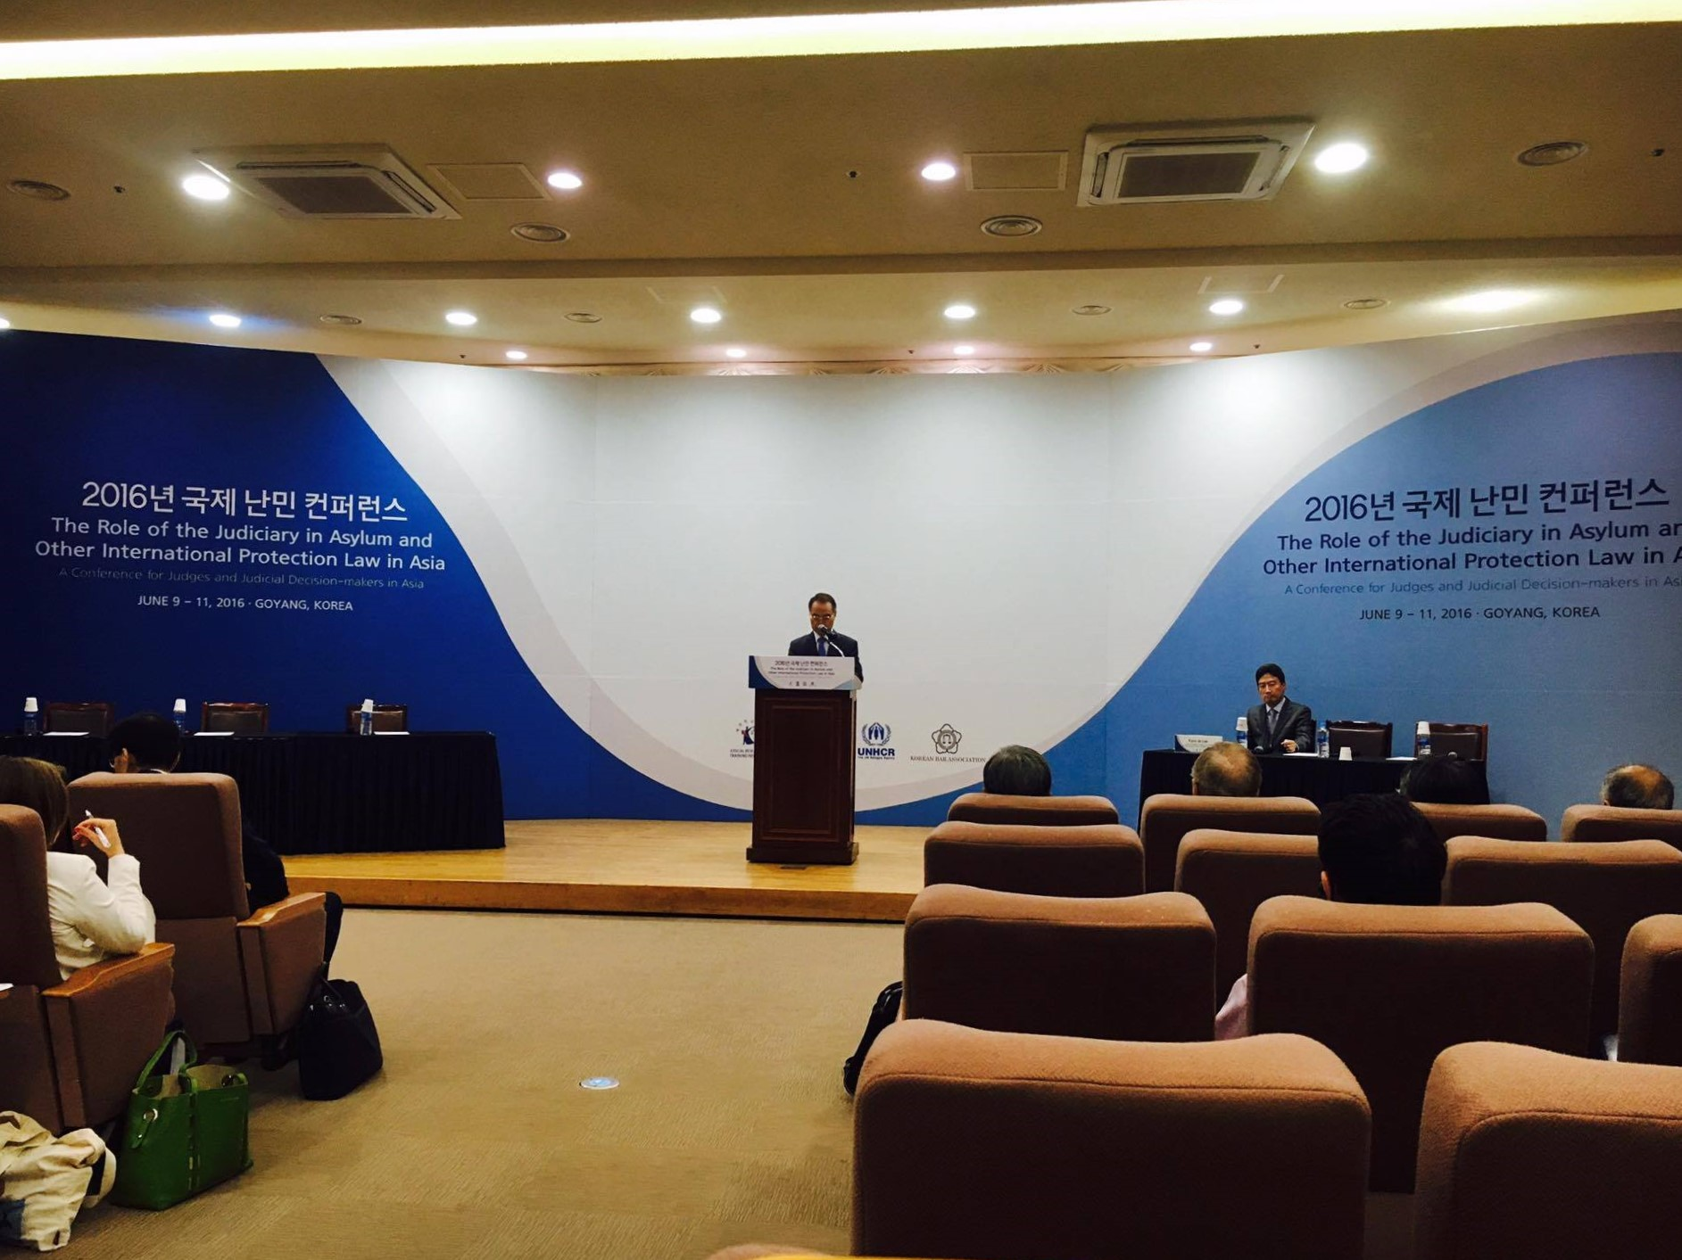

（Opening Ceremony）

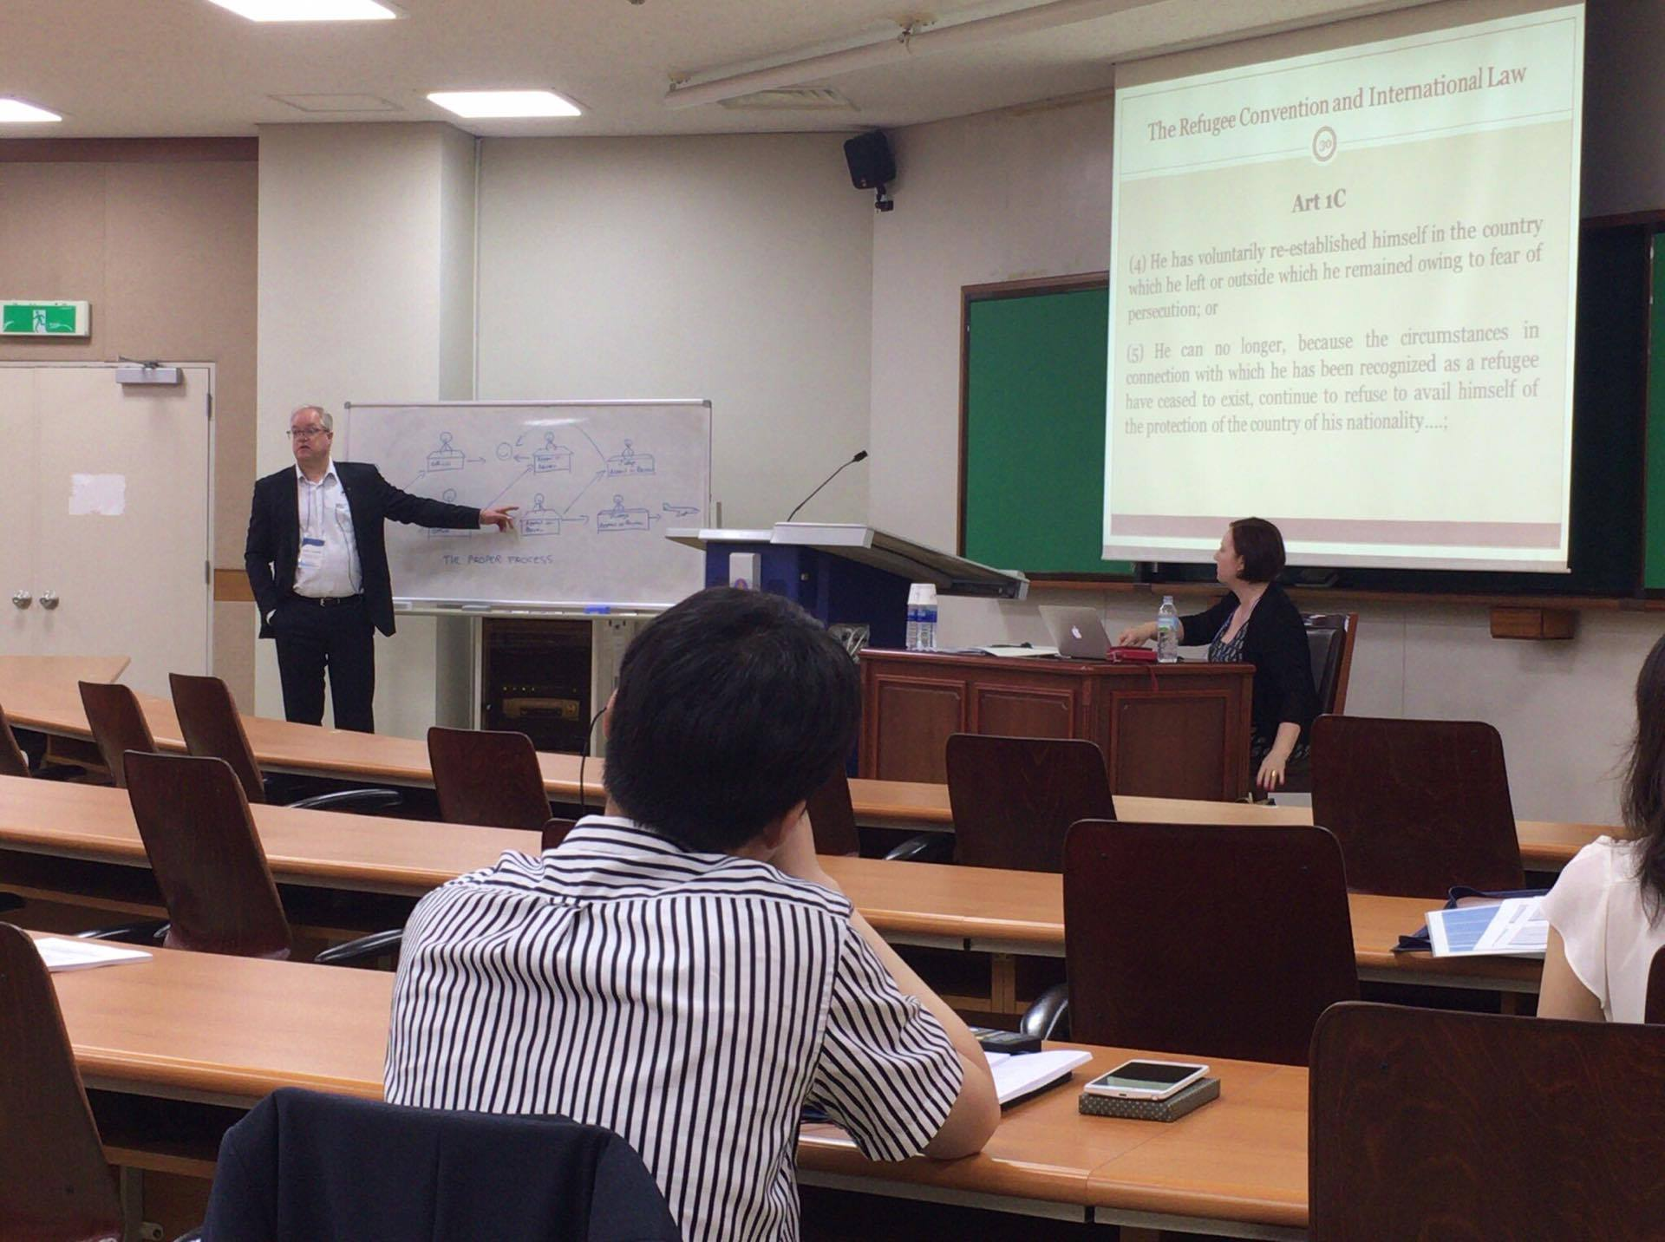

（Workshop）

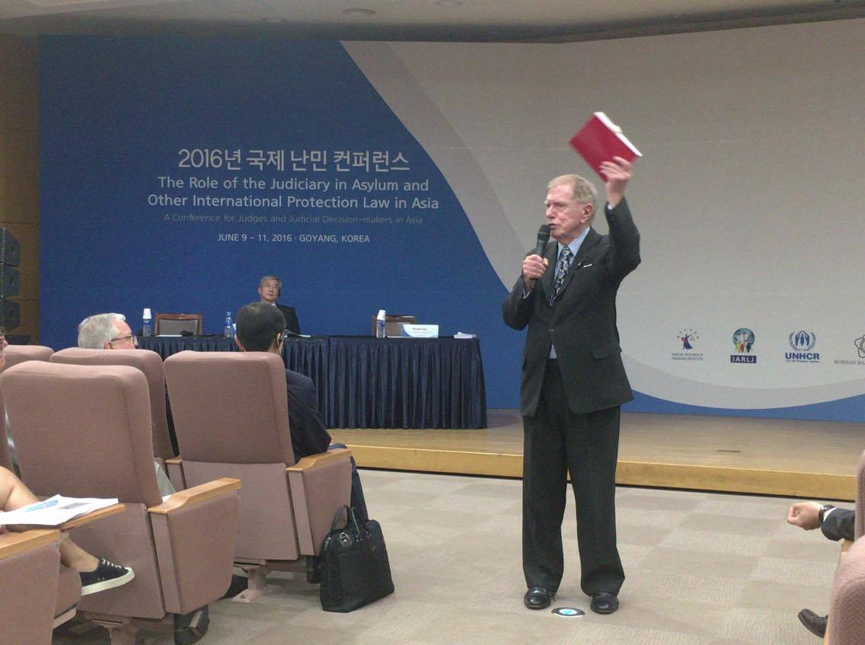

（Conference day 1）

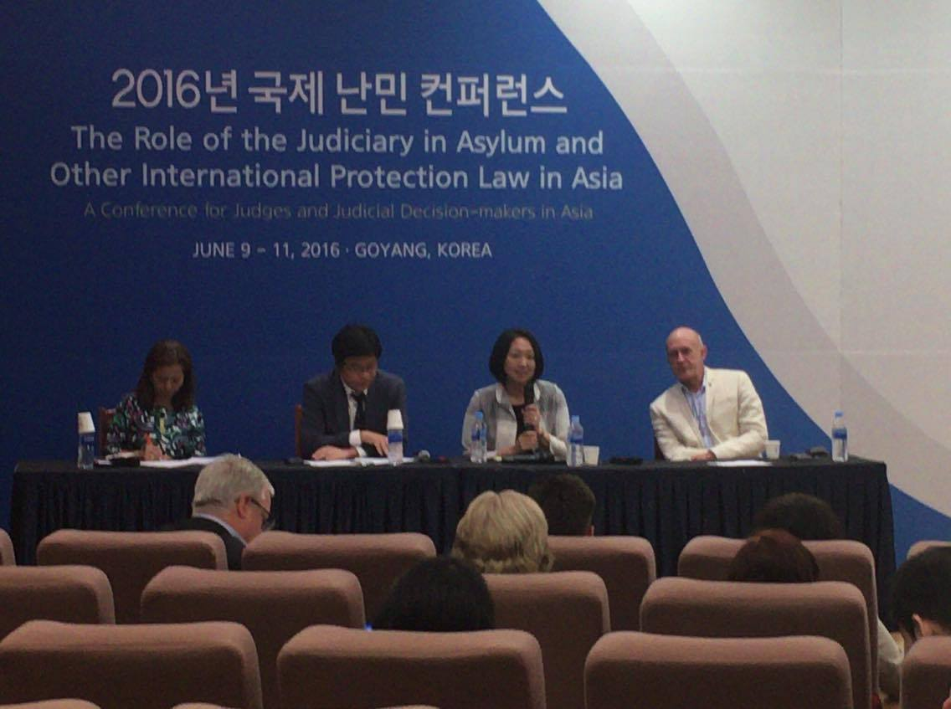

（Conference day2）

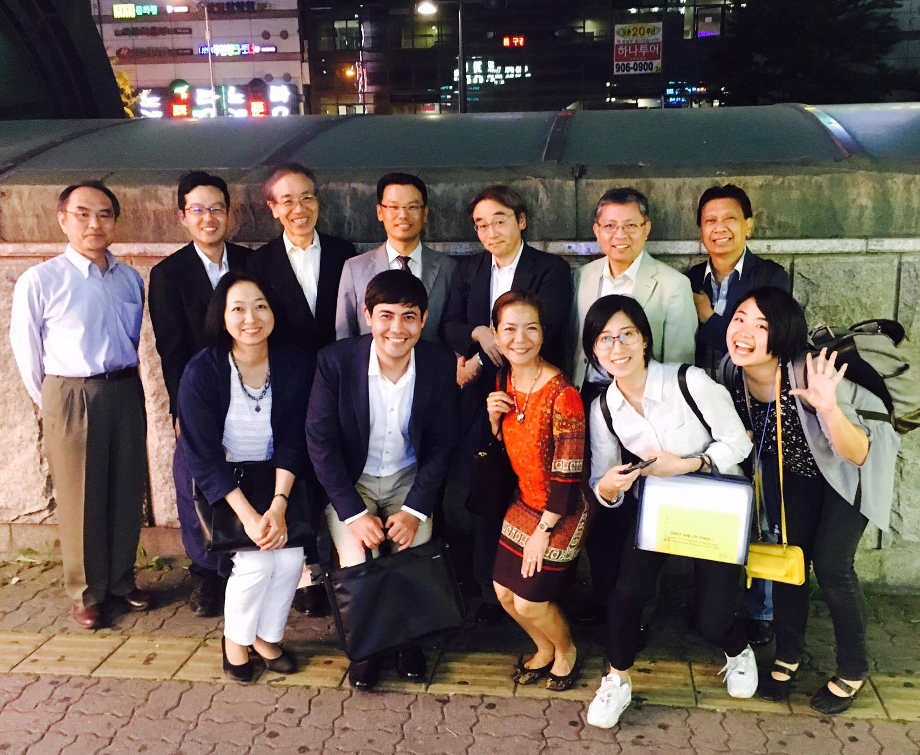

（Participants from ANRIP）